Thinking Globally in the Local Classroom



Piloting Schedule
Teacher | School | Grade/Course | Number of Students
Jennifer Gesior | Rideau High School | Grade 12 World Issues | Approx 25
Denis Monin | Rideau High School | Grade 12 World Issues | Approx 25
Rupinder Johal | Lisgar Collegiate | Grade 12 World Issues | Approx 25
Jennifer Guy | West Carleton Secondary School | Grade 12 World Issues | Approx 25
Claude Brun del Re | Woodroffe High School | Grade 12 World Issues | Approx 25
Tanya Barnett | World Inter-Action Mondiale | Grade 12 World Issues | Approx 80
Renzo Brun del Re | École Béatrice-Desloges (Social Science Department) | Will be in charge of given copies to Social Science teachers at the school and at the Board) | Approx 80

Distribution
Six teachers have agreed to pilot the workshops in their Canada and World Issues, Grade 12 Courses. Besides these six, we will introduce the modules at the professional development day on February 14th and at the Toronto OCIC Global Citizen’s Forum that is usually held in late February. The modules will be distributed to all geography departments in the Ottawa region. We anticipate that on-going assessment will occur through this distribution. Modules will also be available for downloading on the World Inter-Action Mondiale and “Geomatics for High School Curriculum” websites. Evaluation forms will also be available for the teacher to assess the modules on-line.

Evaluation
The principal assessment tool will be the evaluation form by teachers that will be piloting and using the modules. The evaluation form will include a combination of scale rankings and open-ended questions.

The evaluation will include the following:
- Adaptability of the modules to the classroom
- Applicability of the modules to the curriculum requirements
- Receptiveness of students
- Teacher satisfaction with the background materials, the lesson plans research assignments
and resource lists.
- What the teacher like most/least about the modules
- What was most/least useful in the modules
- Recommendations for future resource development

Phone interviews using the same evaluation questions may be used to supplement the written evaluation form.

Analysis
The results of the evaluation will be analysed using SPSS and qualitative techniques such as thematic organization. Finally, all results will be summarised in an evaluation report.

At the moment the site is under construction and it is located at the following URL.
http://www.ocdsb.edu.on.ca/woodsweb/geoindex/
After February 14, the site will be at is final URL location
http://www.ocdsb.edu.on.ca/woodsweb/Geomatics


[ Requirements / Configuration requise ]


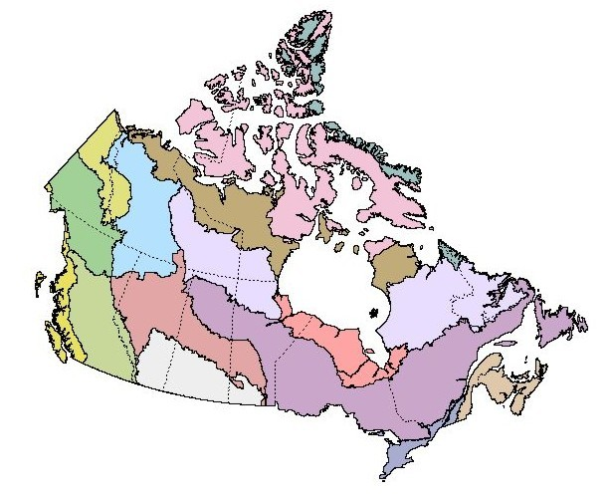 |  | 
Geography of Canada mapped by Ecozones  Grade 9 Academic & Applied courses |  | Thinking Globally in the Local Classroom  Canada and World Issues: A geographic Analysis  Grade 12, University Preparation

Thinking Globally in the Local Classroom

Sustainable Development
Global Economy

This Web Site has been developed with the support and input from the GLOBAL CLASSROOM INITIATIVE, a new CIDA (Canadian International Development Agencies) resource for educators wishing to encourage Canadian youth to actively explore international-cooperation issues. Development of the site has been a cooperative project between NGO's, private industry and high school teachers. The goal of the project "Thinking Globally in the Local Classroom" is to help students develop the skills knowledge, and values they need to become responsible citizens and informed participants of an increasingly interdependent world. This is achieved through activity modules that include background information, fact sheets, resources and Geographic Information System (GIS) lessons on two global themes: SUSTAINABLE DEVELOPMENT and THE GLOBAL ECONOMY. These modules are designed to be a dynamic resource that Ontario teachers can use in the "Canadian and World Studies" curriculum in particular for the Grade 12 course "Canada and World Issues : A geographic Analysis". The modules are also relevant to other Social Studies and Humanities courses in Ontario and in other Canadian provinces.

CIDA  Global Classroom Initiative | GeoInsight Corp. | Woodroffe H.S. | WIAM  World Inter-Action Mondiale | ESRI Canada Ltd. | OCDSB

Special Thanks goes to Claude Brun del Re, Tanya Barnett, Harold Moore, and the students at Woodroffe High School, Trevor Penney, Tina Huynh, Le Hoa Tan for their unrelenting efforts in this project.

Web Site Design by: Michael Sullivan
©Copyright 2002 Geomatics for High School Curriculum Web Site. All Right Reserved

